Lab Report 5

ESE – 3014

EMBEDDED SYSTEMS COMMUNICATION PROTOCOLS AND SECURITY

Submitted to :

Linchan Wang

Submitted by:

Gurvinder Singh(748418)

**1. Simulate the operations performed in the regeneration circuit of the PCM system receiver(like the figure below) include input, amplifier equalizer,timing circuit, decision making device, and output. You should add ap-propriate noise in distorted signal (in your input), and calculate the biterror rate at the end of receiver.**

**Solutoin:**

>>

% PCM ENCODING

f = 5;

fs = 50;

Ts = 1/fs;

fss = 1.e4;

Tss = 1/fss;

t = 0:Tss:2-Tss;

d = Ts/40:Ts:2+Ts/40;

p = pulstran(t,d,&#39;rectpuls&#39;,1/(fs*40));

for i=1:length(em)

if ((((i&gt;1)&amp;&amp;(em(i)~=em(i-1)))||(i==1))&amp;&amp;(em(i)~=0))

x(j) = em(i)-1;

j=j+1;

end

end

% ENCODING MSG

j = 1;

z = dec2bin(x,5);

z = z&#39;;

z = z(:);

z = str2num(z);

s = 2*(z&#39;)-1;

Tb = 2/length(s);

fb = 0.5/Tb;

BL = Tb/Tss;

y = ones(BL,1);

h = 5*y*s;

h = h(:);

h = h&#39;;

% Analog MSG Signal

m = sin(2*pi*f*t)+1.1;

% Sampled signal

ms = m.*p;

% Quantized Msg

qm = imquantize(ms,2/16);

em = 8*(qm);

% PCM DE-CODING

rb = h(ceil(Tb/(Tss)):(Tb/Tss):length(h));

rb = (rb+5)/10;

l = length(rb);

for i = 1:l/5

q = rb((5*i)-4:5*i);

q = num2str(q);

x1(i) = bin2dec(q);

e(i) = x1(i)+1;

end

e = e/8;

y1 = ones(1,ceil((Ts/40)/Tss));

y2 = zeros(1,(Ts/Tss)-length(y1));

y3 = [y1 y2];

y3 = y3&#39;;

ms1 = y3*e;

ms1 = ms1(:);

% Filtering Sampled Signal

[n,w] = buttord(f/fss,(f+1)/fss,.6,4);

[a,b] = butter(n,w,&#39;low&#39;);

rm = filter(a,b,ms1);

rm = rm*50;

% Plotting Signals

figure(1);

subplot(2,1,1)

plot(t,m,&#39;b&#39;,t,ms,&#39;r&#39;);

legend(&#39;Analog Msg&#39;,&#39;Sampled Msg&#39;)

grid;

xlabel(&#39;t --&gt;&#39;);

ylabel(&#39;Amplitude&#39;);

axis([0 2 0 2.25]);

subplot(2,1,2)

plot(t,ms,&#39;k&#39;,t,qm,&#39;r&#39;);

legend(&#39;Sampled Msg&#39;,&#39;Quantized Msg&#39;)

grid;

xlabel(&#39;t&#39;);

ylabel(&#39;Amplitude&#39;);

axis([0 2 0 2.25]);

figure(2);

subplot(2,1,1)

plot(t,em,&#39;b&#39;)

xlabel(&#39;t&#39;);

ylabel(&#39;Amplitude&#39;);

title(&#39;Leveled Signal&#39;);

grid;

axis([0 2 -0.5 16.5]);

subplot(2,1,2)

plot(t,h,&#39;k&#39;)

xlabel(&#39;t&#39;);

ylabel(&#39;Amplitude&#39;);

title(&#39;POLAR NRZ Signal&#39;);

grid;

axis([0 2 -5.25 5.25]);

figure(3);

subplot(2,1,1)

plot(t,ms1,&#39;b&#39;);

title(&#39;Recovered Signal&#39;)

grid;

xlabel(&#39;t&#39;);

ylabel(&#39;Amplitude&#39;);

axis([0 2 0 2.25]);

subplot(2,1,2)

plot(t,rm,&#39;b&#39;);

title(&#39;Recovered Analog signal&#39;)

grid;

xlabel(&#39;t&#39;);

ylabel(&#39;Amplitude&#39;);

axis([0 2 0 2.25]);

In octave

>>PCM Wave

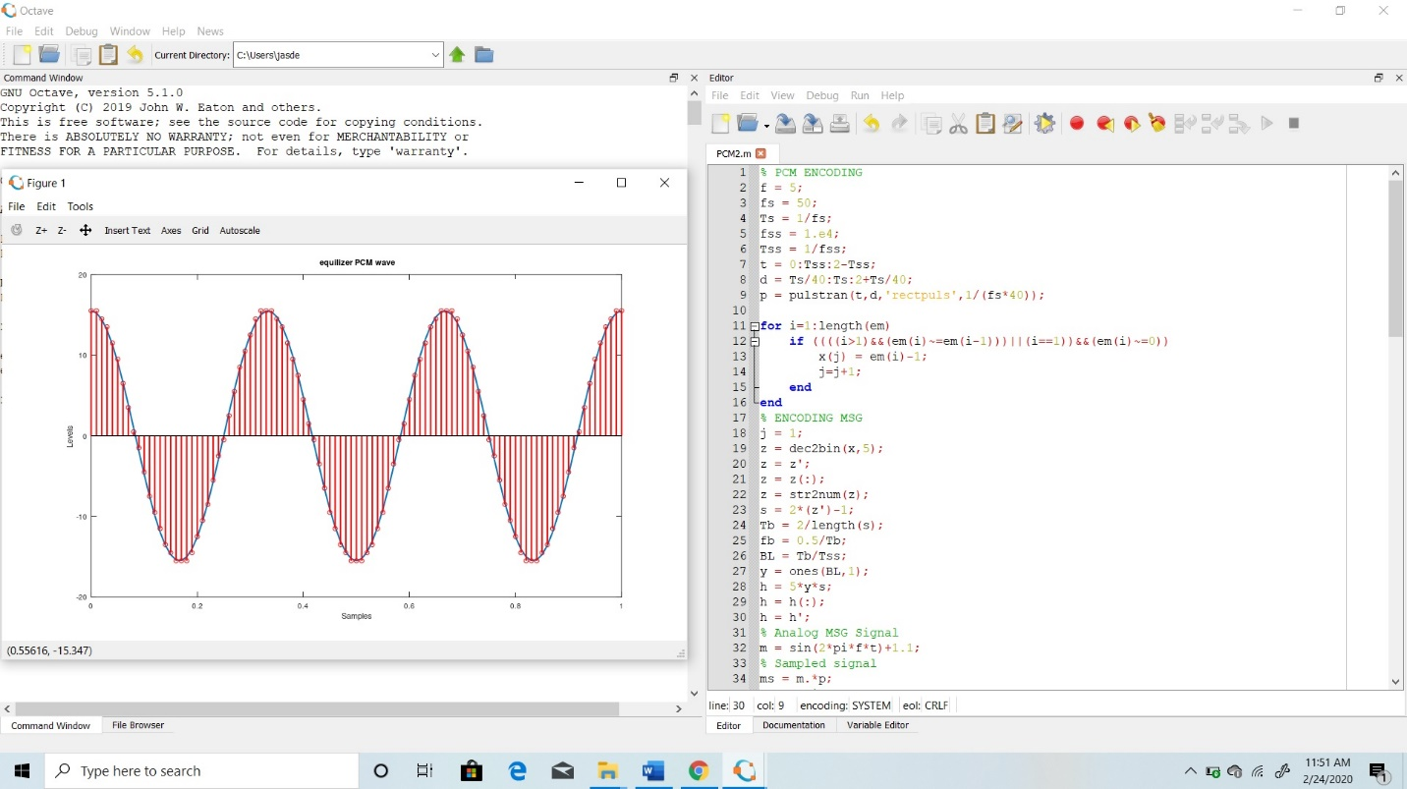

>>Timing Wave

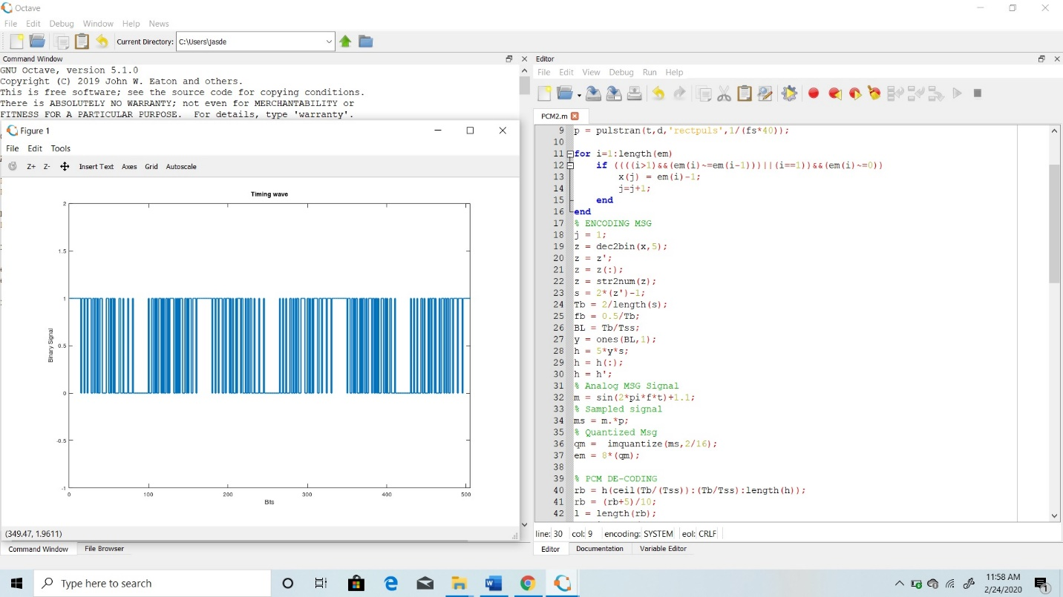

>>Distorted Wave

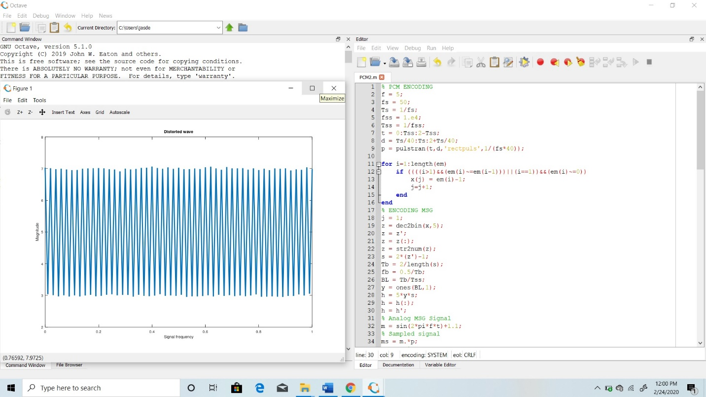

>>Bit Rate Error

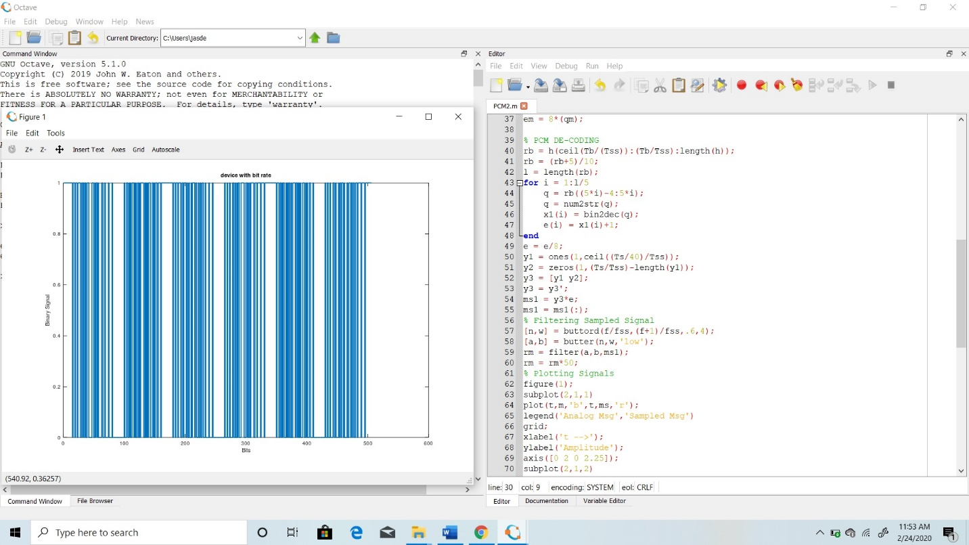

**Note- Combined pictures are not clear so i am adding output pictures separately.**

>>PCM wave

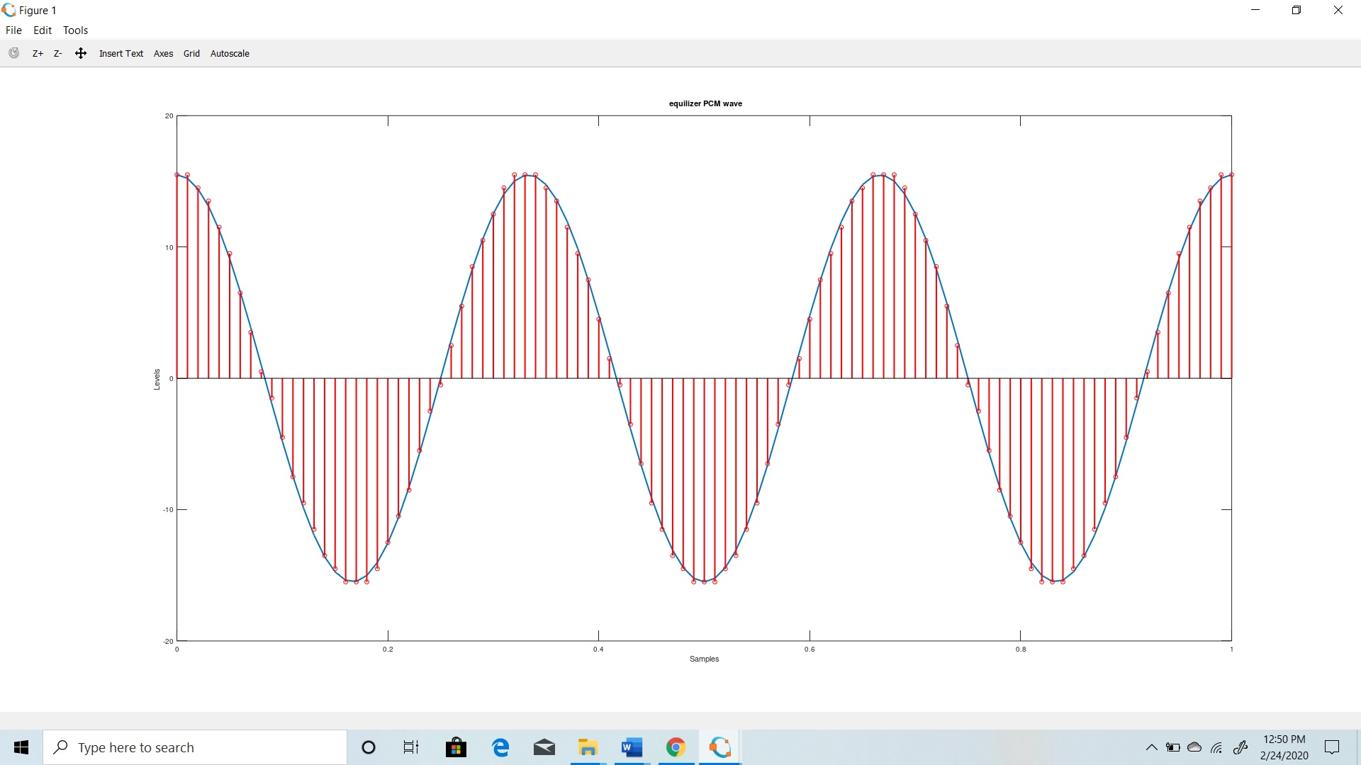>>Timing Wave

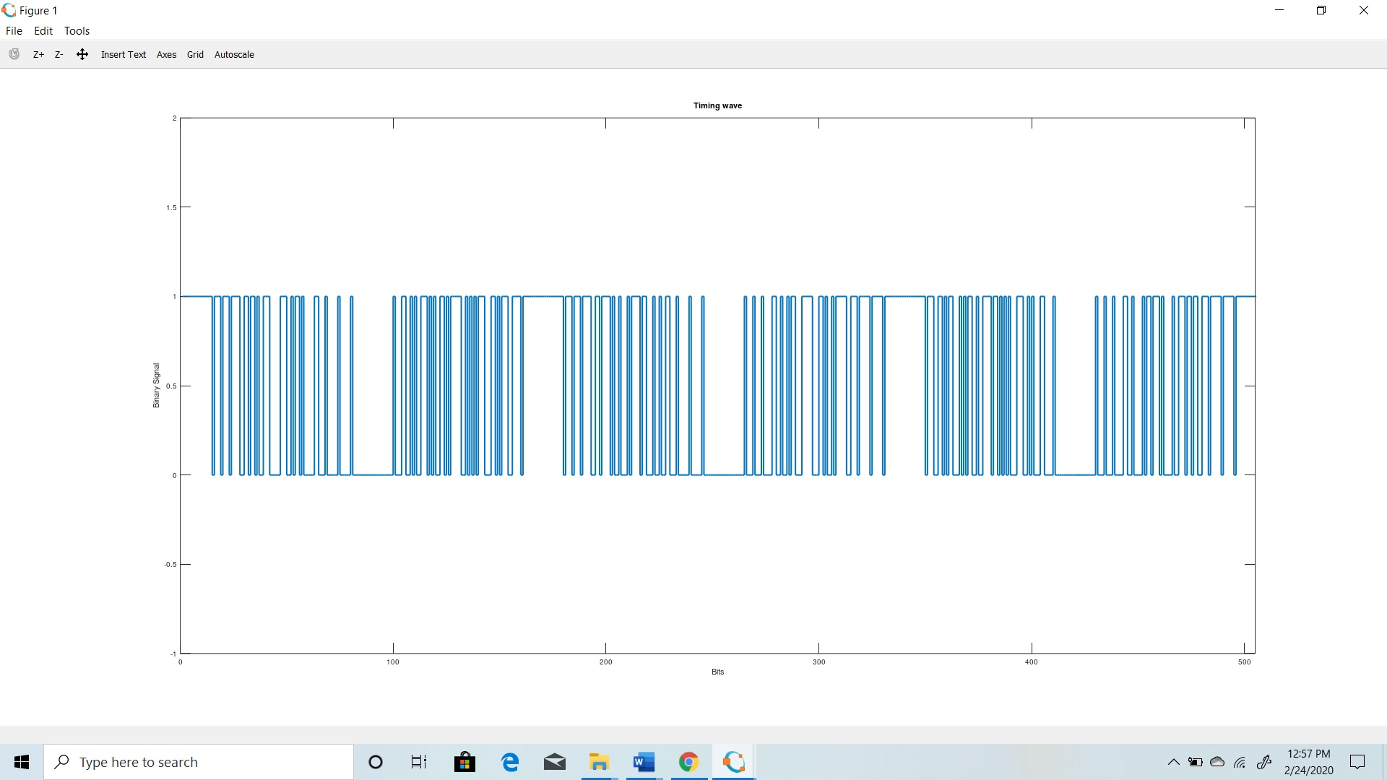

>>Distorted Wave

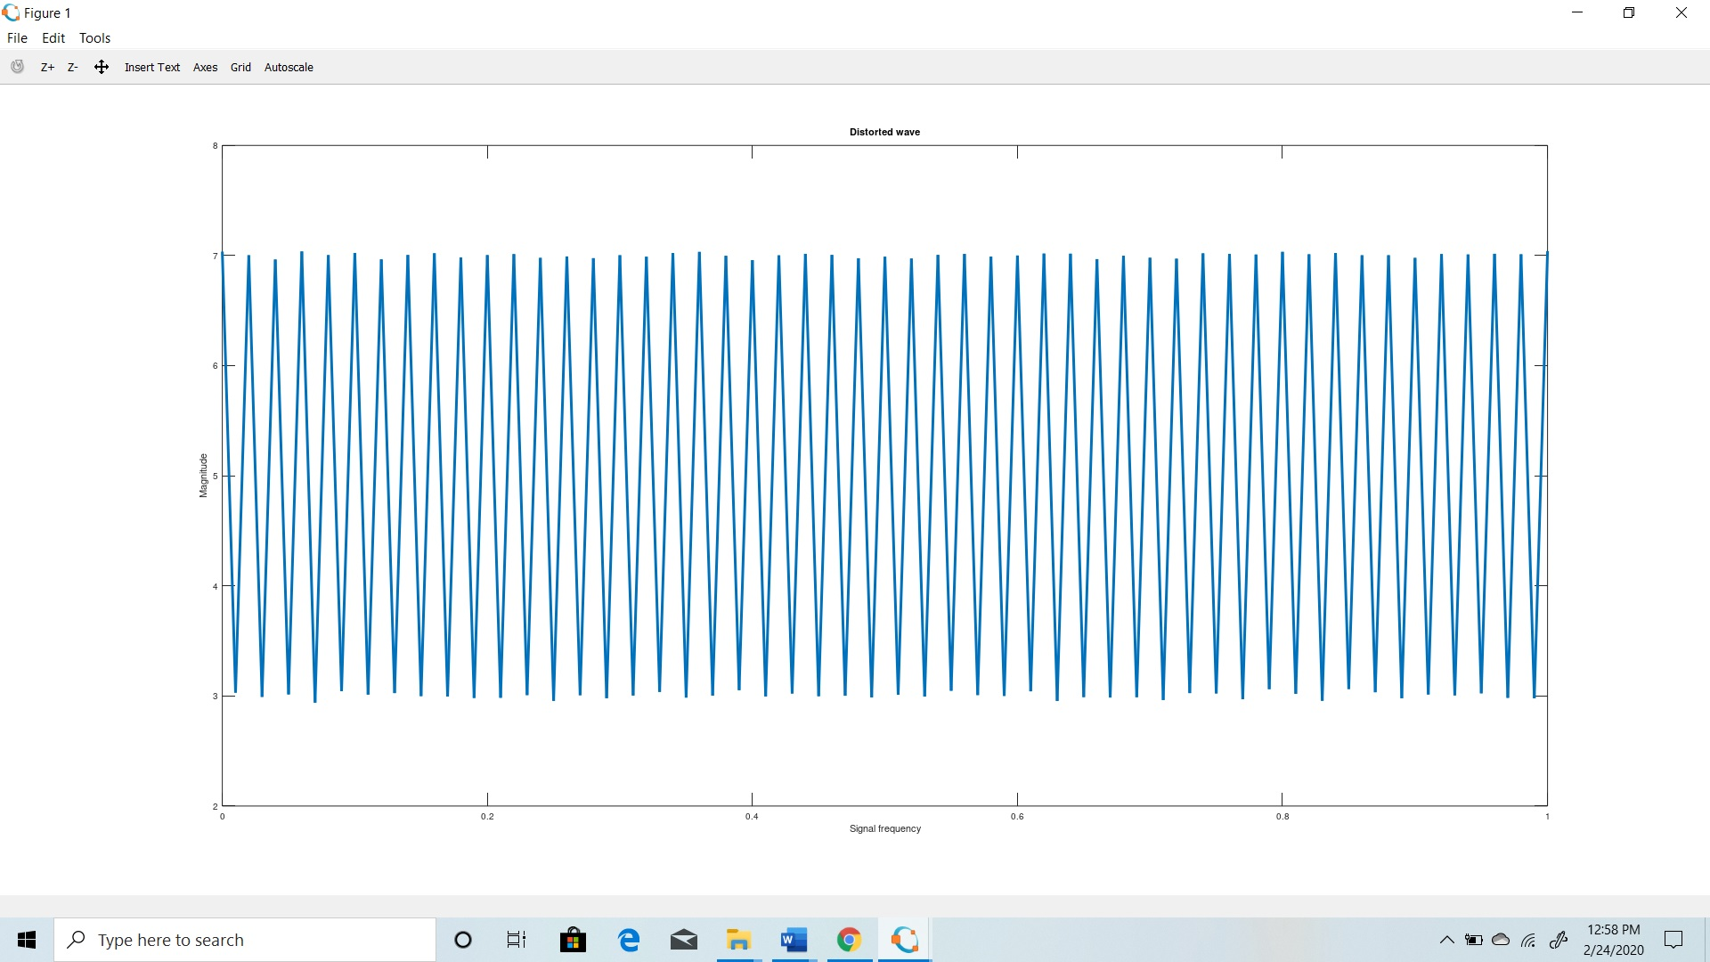>>Bit Rate

